2025-26
Mid-Cities
Event Guide
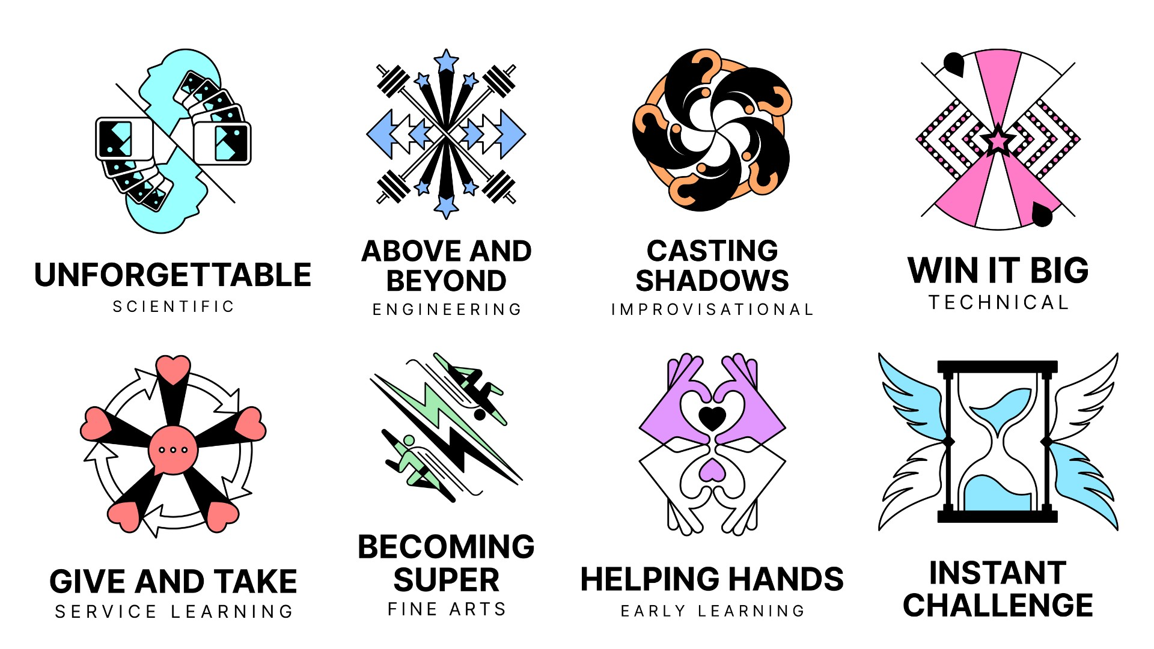

When: February 21, 2026 / Teams begin competing as early as 8 AM and as late as 4:30 / Awards begin at 5:30 for Elementary Teams and at 7:30 for Middle, Secondary, and University Teams.
Where: South Grand Prairie High School - 301 W Warrior Trl, Grand Prairie, TX 75052

Table of Contents
Table of Contents 2
Tournament Information 3
Welcome! Good luck to all teams competing in the tournament! 3
Release/Disclaimer 3
General Schedule 3
Arrival & Check In 4
Parking 4
Entry process (security, ID, etc.) 5
Tournament volunteers 6
Wayfinding information 6
Navigating the Day 6
Team Challenges 6
Instant Challenges 7
Spectators 7
Awards Celebration 7
Photos and Videos 9
What to Wear 9
Inclement Weather 10
Emergency Procedures 10
Other Tournament Events 10
Accessibility Information 11
Language 11
Immunity Precautions 11
Scent-Free Policy 11
Mobility Information 12
Restroom Information 12
Food/Drink & Allergens 12
Sensory Regulation/Quiet Space 12
Lactation Room 13
Accommodation Requests 13
Tournament Accommodation Request Form 13
Code of Consideration 13
Thank You! 14
About DI 15
New to DI? Welcome! 15

Tournament Information
Welcome! Good luck to all teams competing in the tournament!
Thank you to all of our Team Managers, teachers, school sponsors, Appraisers, volunteers, and parents for your hard work to make this tournament possible!

Release/Disclaimer
By my participation in an event conducted by an Affiliate, Region, or other gathering related to the Destination Imagination program, the participant or participant’s parents or participant’s guardian understands and hereby voluntarily agrees to release, waive, forever discharge, hold harmless, defend, and indemnify Destination Imagination, Inc. and its agents, officers, boards, volunteers, and employees from any and all liability and all claims, actions, or losses for bodily injury, property damage, wrongful death, loss of services, or otherwise which may arise out of the participant’s participation in activities related to the Destination Imagination event, including travel to and from the event.

General Schedule
Time | Event | Location
7:30 a.m. | Volunteer Positions Begin | Volunteer Check-In
8:00 a.m. | Challenges Begin (Check in early!)
11:30 a.m. – 1:00 p.m. | Lunch | Cafeteria/Concessions
4:30 p.m. | Challenges Finish
5:00 p.m. | Doors open for Elementary Awards | Coliseum Gym / P100
5:00 p.m. | Pre-awards Party for MS, HS, University | Cafeteria
5:30 p.m. | Elementary Awards Begin | Coliseum Gym / P100
7:00 p.m. | Elementary Awards Finish / Doors Open for MS, HS, and University Awards | Coliseum Gym / P100
7:30 p.m. | MS, HS, and University Awards Start | Coliseum Gym / P100
9:00 p.m. | MS, HS, and University Awards End | Coliseum Gym / P100

Arrival & Check In
Tournament maps will be posted around the tournament site and will also be located on our website.
During the tournament, additional assistance will be available by asking one of our volunteers or by referring to a posted sign.
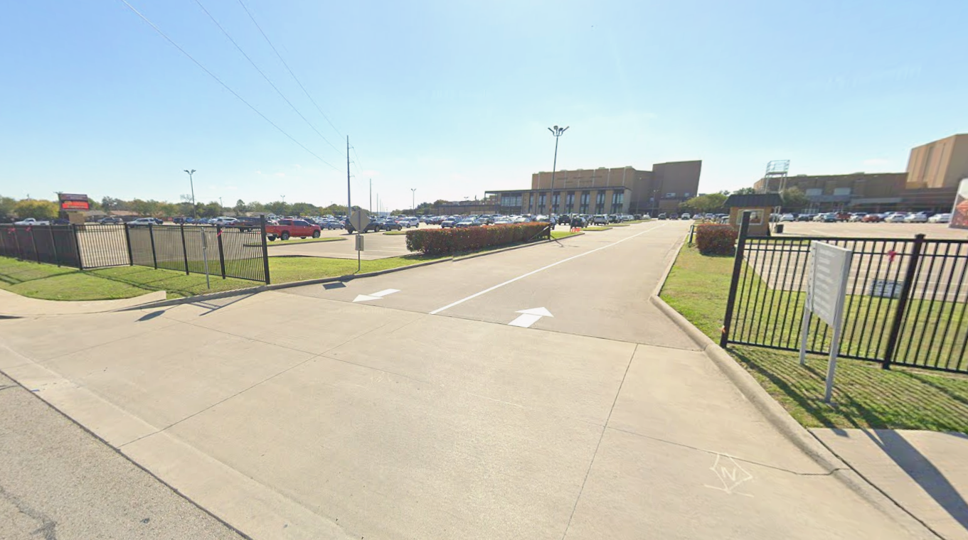
Image Description: A drive leads into a fenced in parking lot of a high school

Parking
- Family car parking is available: There should be ample parking for families and attendees in the main lot. We ask that you don’t park in the long drive that comes in front of the building, as that is purely for dropping off and picking up students. Please be aware that we are sharing the facilities on tournament day with band and basketball. If possible, try to park on the eastern half of the parking lot, nearest Corn Valley Road first.
- Parking for larger personal vehicles such as transport vans or school buses: we ask that you park buses and trailers towards the back of the lot, towards West Warrior Trail.
- Accessible parking is available: Approximately 22 accessible parking spots are available in the main parking lot, and 3 more are available in the ancillary lot near entrance 4 on the map (this is marked primarily as team prop drop off, but these spots will still be kept open for accessible parking)
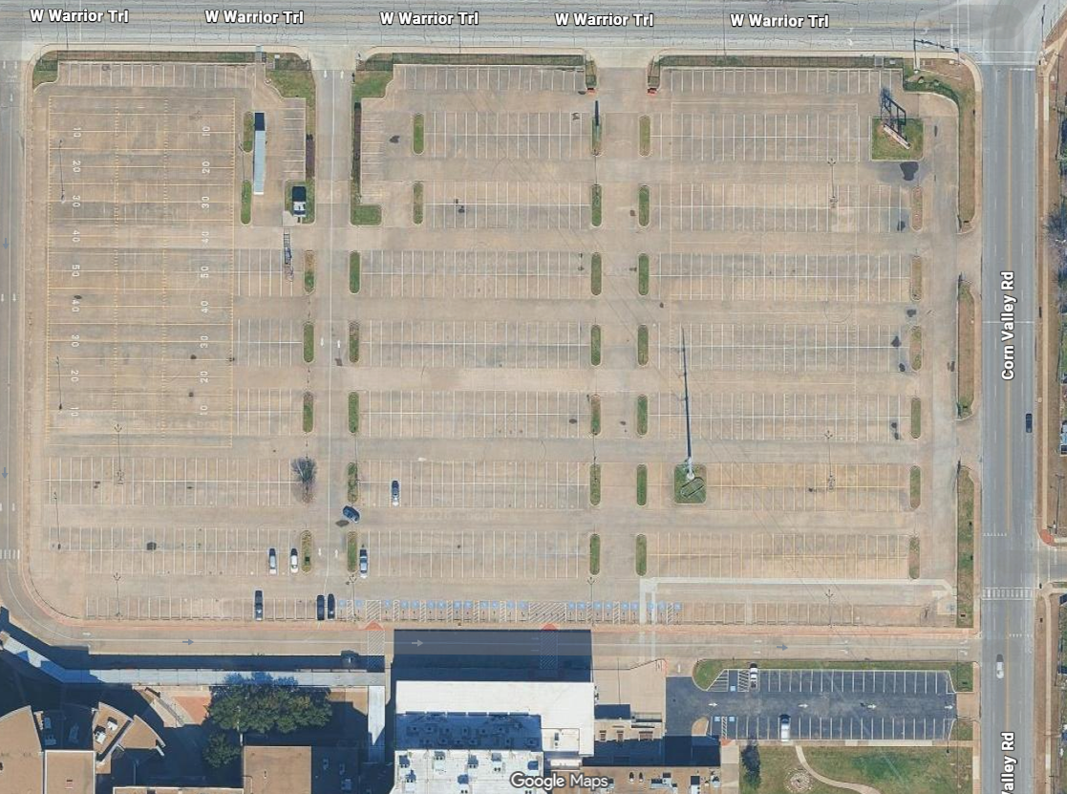
Image Description: An overhead map of the school’s parking lots.

Entry process (security, ID, etc.)
- Entrances to the tournament: We have two entrances to the site. Entrances 1 and 4. Please refer to the tournament map to locate these. They should also be well marked on the day of the tournament. These are the only external doors we are allowed to use. For safety reasons, please do not try to prop open any doors or bring in props through any other entrances.
- Volunteers that are arriving should report to our volunteer check-in, located just past the cafeteria and coliseum gym.
- Teams arriving with props should use entrance 4, if it is available. It offers the easiest point of access for moving large props, without having to lift them over stairs or a ramp.
○ Teams must not block any parking spaces or points of entry while loading, unloading, or moving their props.

Tournament volunteers
- We have many types of volunteers at the tournament. Volunteers can typically be identified by a tan version of the regional shirt, a purple polo, or a red alumni tie.

Wayfinding information
- Tournament maps are provided on our website. Additional assistance will be available by asking our volunteers
- Signage will also be posted around the venue.

Navigating the Day

Team Challenges

Throughout the event, Destination Imagination (DI) teams will be presenting their work on a Team
Challenge. The Team Challenge falls in one of seven categories: Technical, Scientific, Fine Arts, Improvisational, Engineering, Service Learning, or Early Learning. You can learn more about this year’s Team Challenges on the DI website.
Each Team Challenge has its own Presentation Site or rooms specific to the Challenge. The size, seating options, and acoustics will vary greatly by Presentation Site.
The venue map can be found on our website.
The tournament schedule can also be found on our website.
The Presentation is when the team members present how they solved their Team Challenge in front of an audience and a team of Appraisers (scoring officials).
A team’s Presentation lasts eight minutes or less. The content of team Presentations will vary greatly, but it is likely you will see stories, scenery, costumes, and technical elements created by the team members.
- It is common for a team’s Presentation to include lights, possibly including strobe lights and/or flashing lights.
- Team Presentations often include loud noises or music. However, Presentation sites do NOT have sound systems, so it may be hard to hear the team.
- Audience members are welcome to laugh or applaud as they see fit.
Flash photos and/or videos of a team’s Presentation may only be taken if the team has given permission. This information will be announced before the team begins its Presentation.
When the team members are done with their Presentation, the Appraisers will ask them a few questions before they leave. Audience members can remain in the Presentation Site during these questions. After speaking with the Appraisers, the team will take its Presentation materials out of the Presentation Site. Teams are removing ALL materials they brought into the site.

Instant Challenges

An Instant Challenge (IC) is a smaller Challenge that is a surprise to the team on the day of the tournament.
The team, the Team Manager, and the Appraisers are the only people allowed into the Instant Challenge areas.
Instant Challenge sites are quiet zones. No spectators are allowed.

Spectators

Spectators, such as friends and family members, are welcome to attend this tournament. Spectators are welcome to attend any Team Challenge presentation. Please find the doors marked “Audience Entrance” at each Challenge Presentation
Site.
Please note: At many Presentation Sites, doors will be closed whenever a team is presenting, so spectators may be asked to wait to enter the Presentation Site.
Spectators will not be allowed to attend any Instant Challenge presentations.

Awards Celebration

There will be two Awards Ceremonies this year. Both will take place at South Grand Prairie High School in the Coliseum Gym (P100). The first ceremony is for Elementary level teams. Doors will open at 5:00pm, and awards will begin at 5:30. During this time, all Middle, Secondary, and University teams are invited to our pre-awards party in the cafeteria, where they can trade pins, dance, and eat their dinner, while they wait for their ceremony to begin. We encourage teams to grab a bite to eat or be sure to pack one in during this time. The doors to the second awards ceremony will open when the first one ends – 7:00pm. The second awards ceremony for all of our older competitors will begin at 7:30pm. All teams and spectators are welcome to attend. Teams and Team Managers should sit on the gym floor, and spectators should sit in the upper seating area. There will be signs to help guide everyone to the right area.
The following special awards may be presented: DaVinci, Renaissance, Spirit of DI, and Torchbearer Awards.
Place awards will be given for each Team Challenge, based on their Competition Level:
- Elementary Level (EL): Grades 3-5
- Middle Level (ML): Grades 6-8
- Secondary Level (SL): Grades 9-12
- University Level (UL): College/University Students
The amount of teams that advance to State depends on the number of teams competing in the challenge in each level. Lone Star Finals (State/Affiliate) takes place from April 10-11, 2026. If your team advances, there will be a virtual going-to-state meeting held on February 24. In Challenge A, the top 2 Elementary Level teams, the top 2 Middle Level teams, and the top 1 Secondary Level team will advance. In Challenge B, the top 1 Elementary Level team, and the top 1 Middle Level teams will advance. In Challenge C, the top 2 Elementary Level teams, the top 2 Middle Level teams, the top 1 Secondary Level team, and the top University Level team will advance. In Challenge D, the top 1 Elementary Level team, the top 1 Middle Level team, and the top 1 Secondary Level team will advance. In Challenge E, the top 2 Elementary Level teams, the top 1 Middle Level team, and the top 1 Secondary Level team will advance. In Service Learning, the top 1 Elementary Level teams, the top 1 Middle Level teams, and the top 1 Secondary Level team will advance. In Extreme, the top 2 Middle Level teams, and the top 1 Secondary Level team will advance.
Please note: Early Learning/Rising Stars teams (PreK-2nd grade) are in a non-competitive division and are not eligible for Challenge-based awards.
The Awards Celebration is usually a high-energy event with a large crowd and noise. Audience members are welcome to clap and cheer and use ear defenders or earplugs if the noise becomes too loud for them.
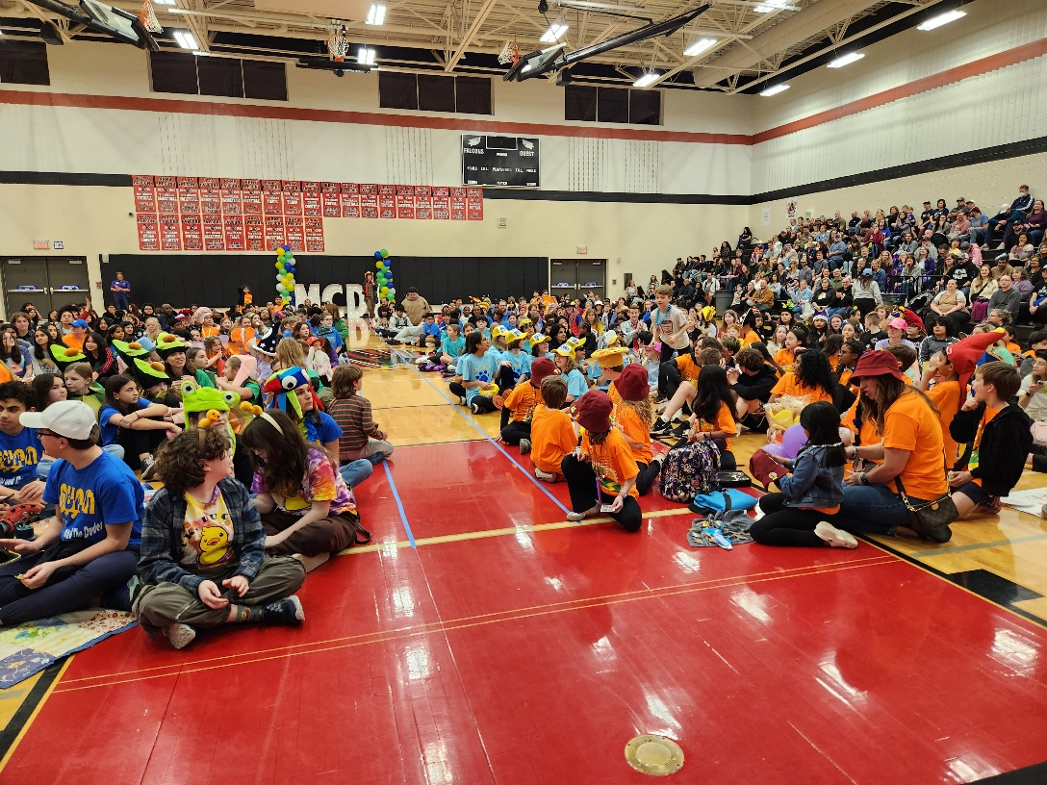
Image Description: A large crowd of students seated in a gym during an awards ceremony

Photos and Videos

- Flash photos and/or videos of a team’s Presentation may only be taken if the team has given permission.
●  What to Wear | This information will be announced before the team begins its Presentation.

- All tournament participants and spectators are welcome to wear comfortable, weather-appropriate clothing.
- Participants must wear close-toed, hard-soled shoes around the tournament, and during their performance (This means no flip flops, slides, etc. even when in costume).
- Our volunteers often wear vibrant, colorful clothing and hats to celebrate the event.
- Team members may be in costume for their Presentations.

- If you prefer using protective equipment such as ear defenders, earplugs, etc., you are welcome to bring them with you to the event.
- We encourage you to wear your most fun hats around the tournament. If you’re looking for a new hat, we will have plenty for sale at the DIme store.

Inclement Weather

- In case of inclement weather that impacts the tournament schedule, teams will be notified via: Remind messaging or our social media pages.
- Tornado shelters will be marked around the school.

Emergency Procedures



- The fire alarms in the building have flashing lights and loud, repetitive sirens.
- If the need for an evacuation arises, please follow posted exit signage to safety.
- Fire extinguishers are located around the building.
- First aid kits are available in the nurse’s office.
- If a medical emergency should occur, immediately call 911. Please notify the nearest tournament volunteer for assistance.

Other Tournament Events
- Bingo – Teams will receive a bingo card with a list of tasks they can complete throughout the day. Upon completing a bingo, they can return their card for a chance to win a prize at their awards ceremony.
- Scavenger Hunt – Teams will be tasked to find hidden objects around the tournament site. Once they have found them all, they will then be entered to win a prize at their awards ceremony.
- Planetarium – One of the amazing things about our tournament site this year, is that they have a working planetarium on the campus. Throughout the day, they have offered to run shows that teams and spectators are welcome to attend.
- Pin Trading – The pinnacle of DI events is back! Participants and spectators are welcome to bring their pins and trade with each other throughout the day and during the pre-awards party for our older participants. If you’re newer to DI, our DIme store will have a limited number of grab bags of pins for sale to help get you started.
- DIme Store – Located in the cafeteria, our DIme store will have a large variety of pins, hats, and other souvenirs that will help make the tournament a day to remember. Since our theme is Excavation Imagination, I hear there just might be some fun dinosaur themed items in stock this year.

Accessibility Information
Destination Imagination is committed to being as inclusive and accessible as possible. We are eager to meet your needs! This section outlines the accessibility features in place. If you or a member or members of your team could benefit from further accommodations, you can fill in the Tournament Accommodation Form found later in this document.
● On-site accessibility contact for the tournament day: Margaret Wirick at Mars.wirick10@gmail.com

Language
- The Awards Celebration language: English

- Most Team Presentations will be shared in: English
- Signage language: English
- If a team or team member wants/needs to present in a different language or would otherwise benefit from having a language interpreter present, please contact Peyton Murrell at pmurrell@att.net as soon as possible.
- If a team member or spectator needs a sign language interpreter or another type
of assistive communication technology (including but not limited to: amplification devices, picture/letter boards, audio description), please contact Peyton Murrell at pmurrell@att.net as soon as possible.

Immunity Precautions

- Our event will adhere to local health and safety restrictions. At this time, masking and vaccinations are optional.
- To be respectful of those with compromised immune systems, please do not attend if you are experiencing an airborne or contagious illness.

Scent-Free Policy

● Out of respect to those with sensitivity to scent, please avoid wearing perfumes or colognes.

Mobility Information

- Number of accessible parking spaces: 25
- From the accessible parking, the best entrance is 1 or 4, which is approximately 75-100ft from the parking area.
- Elevators are available in the following locations: Around the Coliseum Gym and near a stairwell (look for signage)
- The following event spaces are on upper floors: Instant challenge and seating in the Coliseum Gym
- The following event spaces have alternate access for visitors utilizing wheelchairs, walkers, or other mobility aids: entrance 1.
- Presentation Sites are located throughout the venue. We recommend bringing your mobility device with you to help manage the distances between sites.

Restroom Information

- Restrooms divided by gender can be found throughout the school, usually near stairwells.
- All bathrooms should have accessible stalls, meaning they can accommodate people who use mobility aids and have grab bars.

Food/Drink & Allergens

- Food and drinks will be available in the cafeteria
- We have asked our vendors to post any allergens alongside their signage.
- Teams and spectators are welcome to bring their own food and drinks.
- We ask that you enjoy your food and drinks in the cafeteria, NOT in any performance space.
- This is not a latex-free or peanut-free site. Please be aware that these allergens may be present.

Sensory Regulation/Quiet Space

- A Sensory Regulation/Quiet Space is available upon request. Please speak to a volunteer in a purple shirt, if one is needed.
- This space is reserved for attendees who may need a quiet space for tasks like taking medication, prayer, addressing sensory needs, or just a moment away from the busy tournament.
- While using the Sensory Regulation/Quiet Space, please use a quiet voice and silence all devices except Augmentative and Alternative Communication (AAC) devices.
- Attendees under the age of 18 should be accompanied by an adult.

Lactation Room

● A private space exclusively for nursing parents can be found near or in the hospitality room.

Accommodation Requests
Destination Imagination is committed to providing accommodations for all participants. Please let us know if one or more of your team members need accommodation during their Team Challenge or Instant Challenge by filling in the Tournament Accommodation Request Form:
Tournament Accommodation Request Form
● Must be received by February 14, 2026.
Our Educational Experience Team and your local Affiliate Director will review your request and provide a response within 3-5 business days.

Code of Consideration
We aim to co-create a welcoming space for everyone. Please:
- Avoid perfumes, colognes, or scented lotions.
- Use quiet voices in sensory or rest areas.
- Respect personal space and mobility devices.
- Ask before touching assistive tools or service animals.
Thank you for helping make this a more inclusive, creative, and respectful experience for all!
Disclaimer: While we are not in charge of the building and cannot guarantee it meets specific accessibility laws or standards, we do our best to advocate for access, provide accommodations, and choose venues that are as accessible as possible.
Thank You!
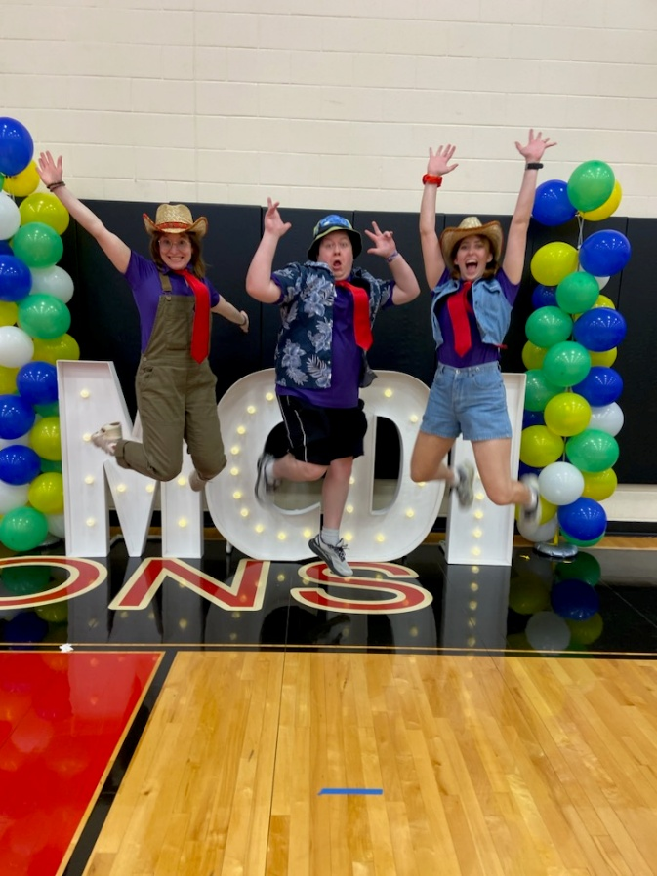
Thank you for attending our tournament! Throughout your experience, if you need to ask questions, offer feedback, or request accommodations, you are welcome to contact us at stellagreer@midcitiesdi.org

Image Description: Three alumni volunteers jump in celebration

About DI

Mission
To inspire and equip youth to imagine and innovate through the creative process

Vision
Ignite the power of ALL youth to be the creative and collaborative innovators of tomorrow

New to DI? Welcome!
We’re glad you’re here! There’s no better way to understand the Destination Imagination Challenge Experience than to see it in action. To get the most out of your day at this tournament, here’s what we suggest:

- Attend at least one Presentation in every Team Challenge. Each Team Challenge is unique and has open-ended requirements, allowing teams to create totally different solutions from one another. Read through the Points of Interest so you know what you can expect to see. Each Presentation is around eight minutes in length.
- Wish the teams luck in their Instant Challenge. All of our teams participate in an Instant Challenge as part of their tournament experience, during which they use quick, creative, and critical thinking, and teamwork to come up with a solution in a short amount of time. Spectators are not allowed in these presentations as the Instant Challenges themselves are highly confidential.
- Look at the props, costumes, sets, technical devices, and more that the teams have created—but please don't touch! Remember that everything you see was crafted by the team members with no adult Interference.
- Talk to teams, parents, and volunteers about their experience with this season of Destination Imagination. Tell them you’re considering starting a team, and ask them to share their favorite thing about DI—you’ll be amazed by the different answers you hear.
- Have fun, be inspired, and imagine the possibilities!

Learn more at DestinationImagination.org. Sign up for our newsletter for all the latest updates and to be alerted when registration is open for the 2026-27 season.

Learn more at DestinationImagination.org

